
Luxembourg, 23.10.2026

Two-day excursion to Essen, Germany:
Saturday 10 and Sunday 11 October 2026

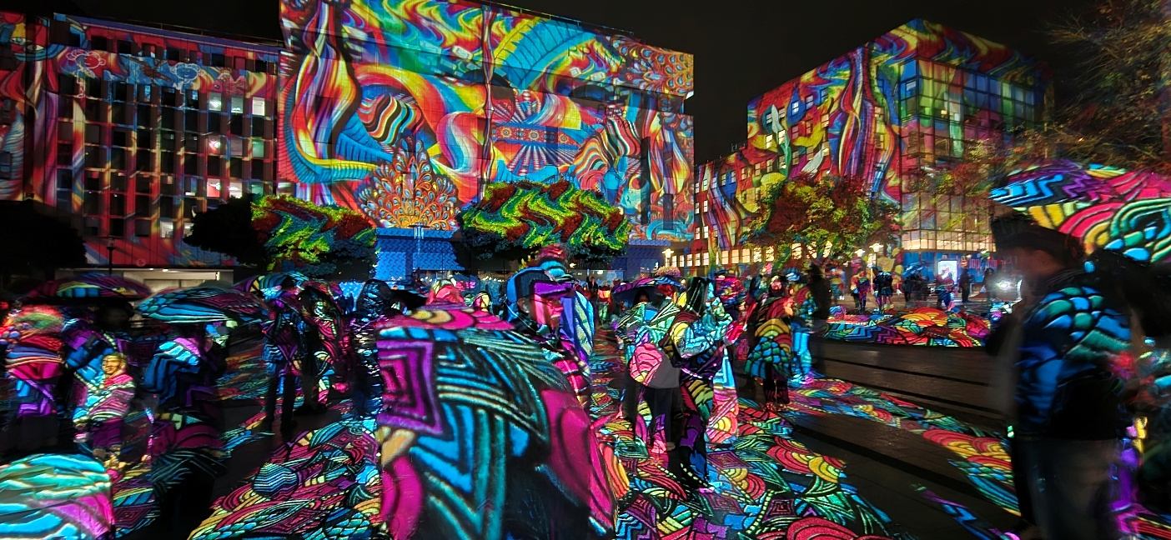

Saturday 10 October 2026

Despite the early start, 26 intrepid art history enthusiasts set out punctually from the Glacis parking lot at 07:00 towards Germany to explore Essen, Germany’s 10th largest city, located in the heart of the Rhine-Ruhr metropolitan area and formerly a dominant heavy-industry, coal, and steel centre built by the Krupp family. The bus stopped briefly at P+R Wasserbillig/Mesenich to pick up a further 4 participants.
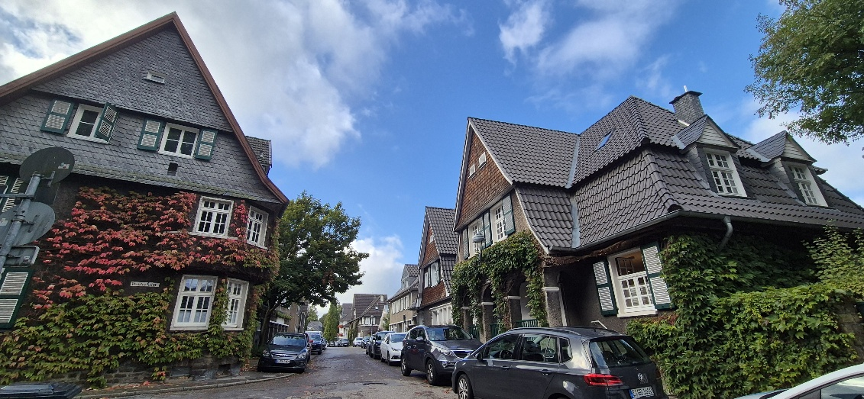

After a smooth four-hour drive, the group arrived in good time at Margarethenhöhe, renowned as Germany's first "Garden City," The participants were already impressed by the approach to the estate along the Sommerburgstrasse thoroughfare featuring charming heritage houses covered in thick ivy and grapevines, mature trees, lawns and hedges and green integrated tram lines with bright red and electric streetcars. They were split into two groups for the planned 1.5-hour walking tours in French and English. The tour guides provided some background information on the project which was started in 1906 by Margarethe Krupp to mark the wedding of her daughter, Bertha. The goal was to provide healthy, light-filled, affordable homes with gardens and green spaces for white-collar workers and municipal civil servants, away from crowded industrial tenements. Developed by architect, Georg Metzendorf, and built across 29 phases between 1909 and the late 1930s, the design avoided monotonous rows. The guides pointed out that almost no two houses are identical: details like arched gables, bay windows, timber framing, and stone foundations give the settlement a picturesque, almost medieval village feel. They also highlighted the original social layout including the Am Brückenkopf gatehouse and sandstone viaduct, separating the peaceful garden city from the industrial urban centre, the market square and fountain, cooperative consumer stores (Krupp Konsum), meeting places, the school and the surrounding wooded valleys (Siepentäler) for recreation and self-sufficiency. The tours under blue skies were rounded off with a look inside an historic model apartment with its pioneering heating system.
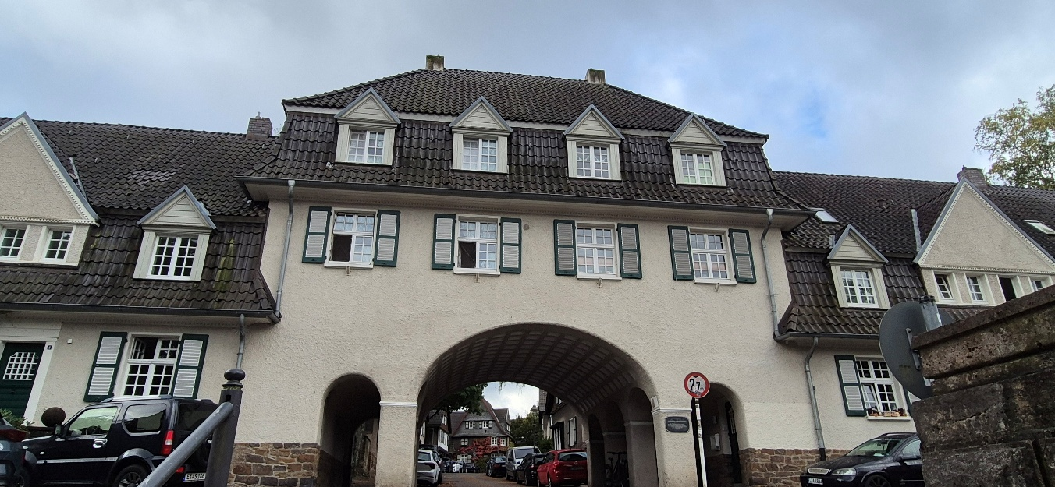

The group was then transported by bus to the Südtiroler Stuben restaurant sitting on the edge of the Baldeney Lake for a hearty lunch with superb lakeside views, rounded off by generous slices of apple strudel. Unfortunately, the weather changed for the worse during the lunch break and umbrellas appeared.

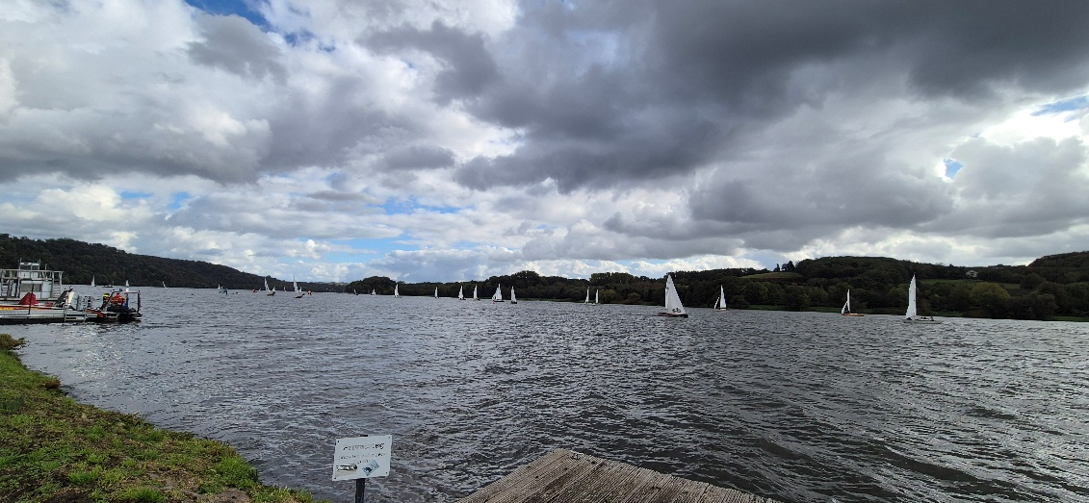
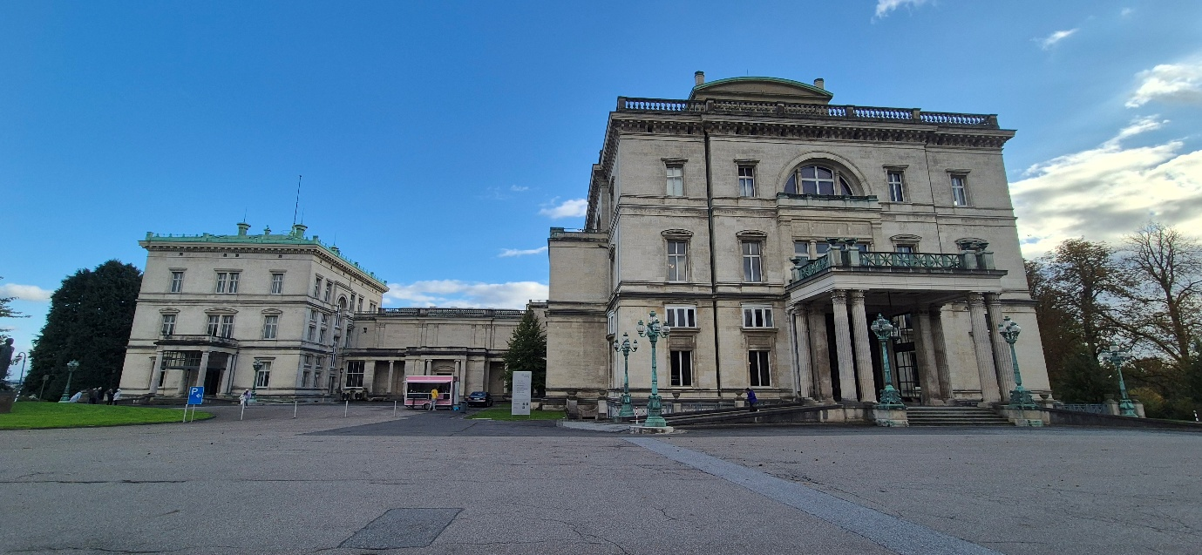

The next stop was Villa Hügel, the historic 19th-century residence of the prominent Krupp industrialist family. The group participated in a guided tour of the massive, 269-room mansion, learning about its unique history, modern-era technological innovations for its time, and the family's immense influence on German industry, touching upon private family scandals and the darker history of supplying weapons and ammunition during both World Wars. Highlights included the private apartment used by the German Emperor, the massive central hall and grand library.
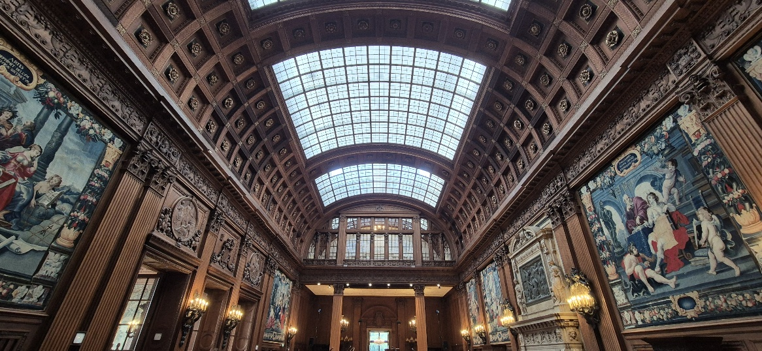
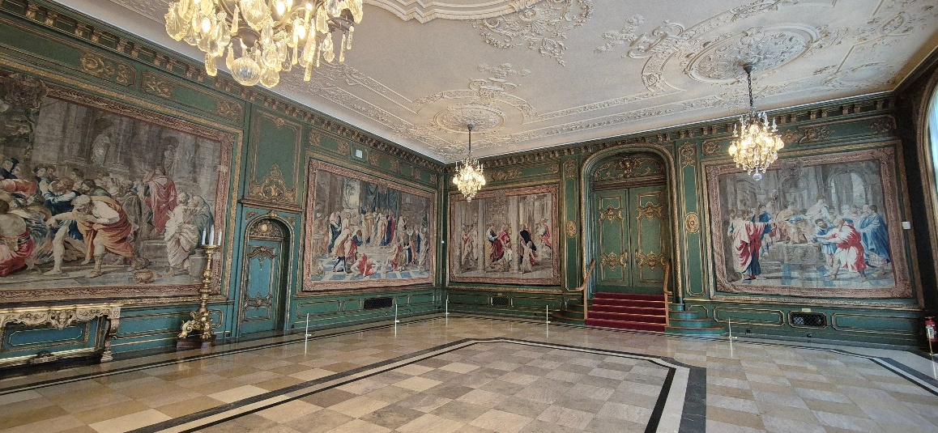

After checking into the hotel, some participants braved the rain showers and made their way into the city centre on foot where they were delighted to stumble upon a major light festival, starting at sunset and consisting of 13 light installations along a walking route from Willy-Brandt-Platz and the main station through shopping streets and historical squares to the university quarter. They enjoyed the 3D-video mappings on landmark buildings, interactive light sculptures, laser shows in churches, and large-scale projections, while recharging their own batteries from outdoor food and drink stands similar to those found at Christmas markets.
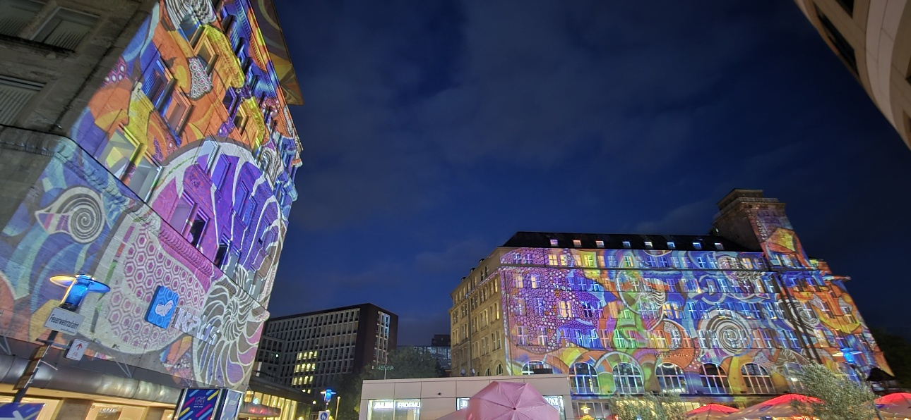

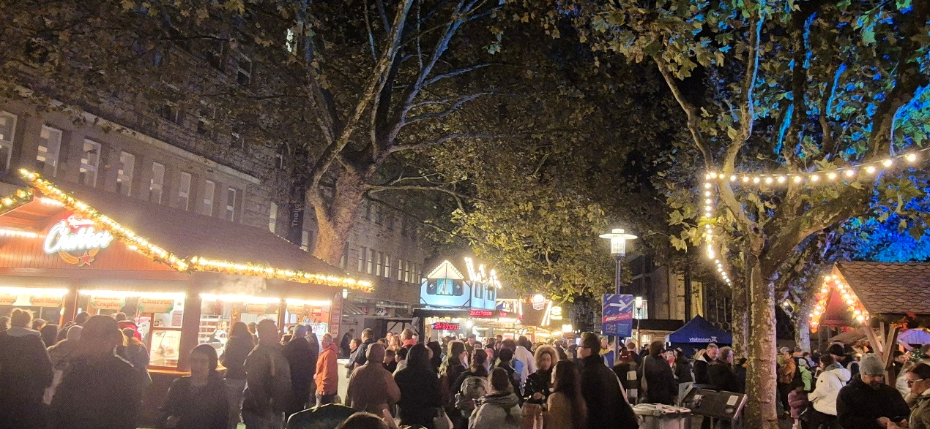

Saturday 10 October 2026
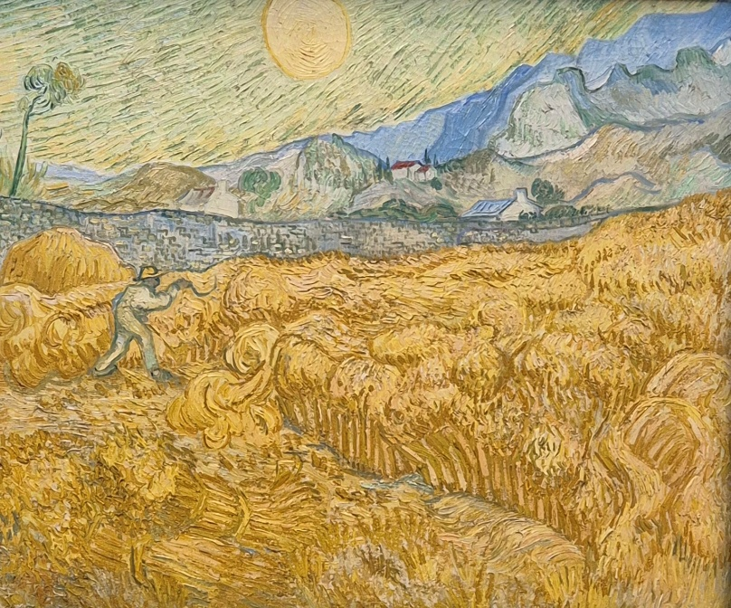

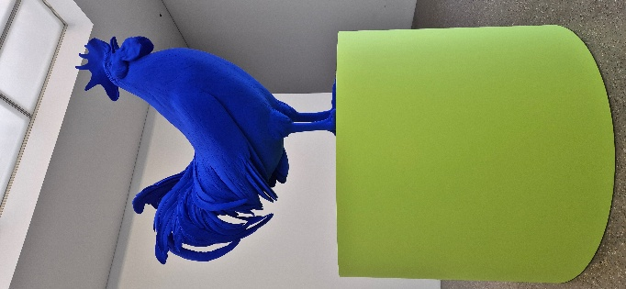

The day began with breakfast at the hotel, after which the group checked out, stowed their luggage in the bus and headed to the nearby Folkwang Museum. A specialised guided tour introduced the group to its internationally acclaimed collection, including outstanding works of 19th-century art, French Impressionism, Expressionism, and modern art movements. Participants admired masterpieces by world-famous artists such as Rodin, Gaugin, Van Gogh, Marc, Fritsch, Dix, Mondrian, Pollock,.... Initially the works appeared to be displayed somewhat haphazardly, but it was explained that the rooms are organised according to themes rather than periods, media or artists. During the lunch break, some participants opted to visit the temporary “I, Gustave Courbet” exhibition, featuring roughly 100 items, divided into nine thematic areas spanning self-portraits, landscapes, and the artist’s time in Swiss exile. Due to time constraints, it was not possible to appreciate the exhibition in full but nevertheless it was a good opportunity to see major pieces like L'Origine du Monde and L'Homme à la pipe.

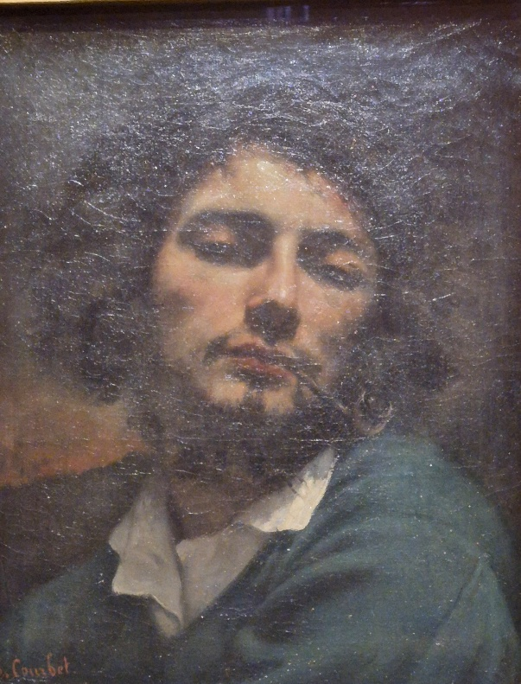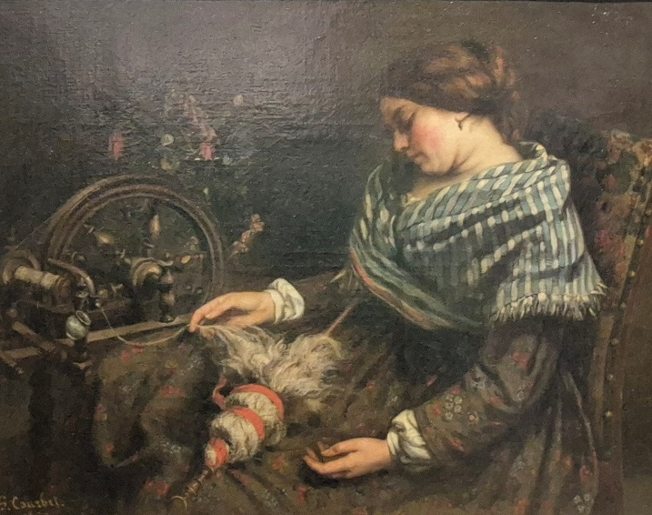

The final leg of the trip took the group slightly north of Essen to the historic Henrichenburg Boat Lift (Schiffshebewerk Henrichenburg) in Waltrop. As part of the Westphalian State Museum of Industrial Heritage, this massive 1899 structure represents a milestone in canal engineering. The visit began with a relaxing boat cruise on the canal with loudspeaker commentary and views of the local locks, lifts and power station. The group was then given a guided tour of the historic mechanism that once lifted 350-tonne barges over a 14-metrer drop and the neighbouring museum. The guide outlined the history of the lift and the technology deployed with a practical demonstration on a model.
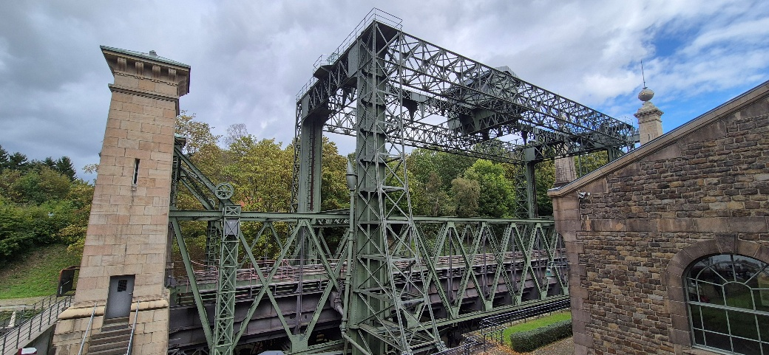

Following the visit, the group boarded the bus for the return journey to Luxembourg, arriving at the Glacis car park at around 21.30 after dropping four participants off at Wasserbillig en route.

